Monday – August 17, 2015

**Discovering How The Electronics Work**

**Goals:** Tonight, we are meeting with PHI Omega at their garage, to discuss the plans for the AV Fair. The current plan is to bring our robots, and last year’s field, and demonstrate to the public what robotics is, and get them interested. We will be discussing the particulars such as which team is there at what time, and which members are going. If we have time after discussing the fair, we are going to do some research on how to set up and use the new electronics system.

**Accomplishments:** We finished planning the schedule for the AV Fair, we assigned team members time shifts. After that, we drove back to our garage and began to play with the electronics. We were nervous that it wouldn’t work at first, but the setup was simpler than expected, and is very well explained.

**Plans:** During the next meeting, we will be focusing on preparing the robot, for the demonstration at the AV. Fair. We will also attempt to get some motors to turn using the new equipment.

**Author:** Timothy Bloot



**Notebook And Researching**

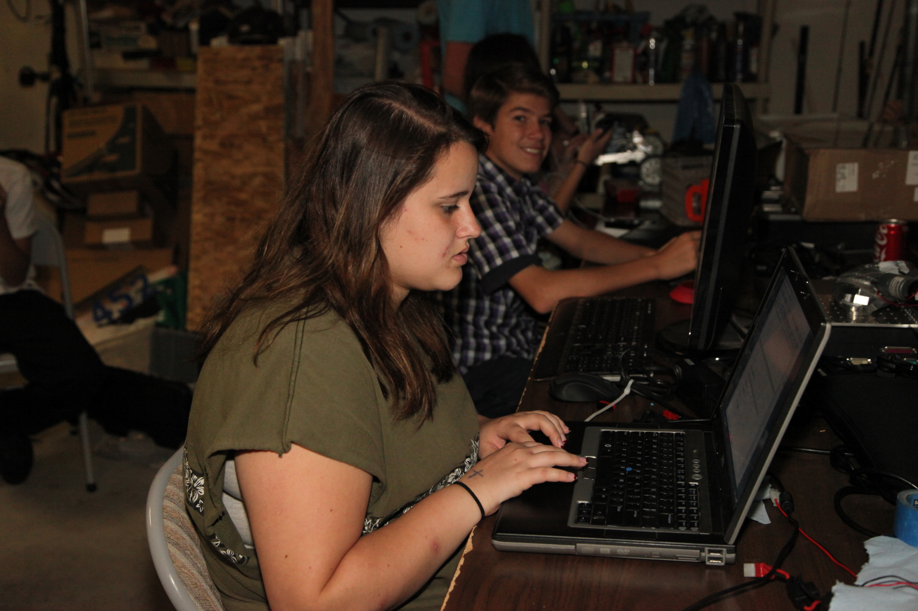

Thursday – August 20, 2015

**Jethawks Fundraising and Getting Ready for the AV Fair**

**Goals:** Sell Jethawks game tickets, prepare our robot, put a spare parts kit together, experiment with the new phones.

**Accomplishments:** Tonight, two of our members went around door to door selling Jethawks tickets as one of our fundraisers. We talked about our team and how we are a non-profit organization, and that we have to make up some of the money ourselves. through fundraisers. The rest of our members prepared our old robot from last year for our outreach at the Antelope Valley Fair. We had to re-install a trial version of Robot C, since we wiped our old license out when we upgraded our computers. We put together a "go" kit, to help us fix any issues during the fair. We spent the rest of the night preparing our phones for the new season. The instructions from the first website were invaluable, we would have never figured out how to configure them on our own.

**Discoveries:** We had to re-install a trial version of Robot C, since we wiped our old license out when we upgraded our computers. Once we installed the Software we were able to load our old programs, and return the robot to good working order.

**Plans:** Get a powered setup of the new hardware and begin programming

**Author:** Cierra Bachtelle



Thursday – August 27, 2015 (Alpha and Omega Meeting)

**Stripped Robot Down To The Bone**

**Goals:** Get a powered setup of the new hardware, and begin programming.

**Accomplishments:** We had a group meeting tonight, our mentor set our objectives, which included starting a bill of materials (B.O.M). Try to figuring out the new programming ways, breaking down the old robot, and establishing roles, and responsibilities for the new year. Tonight we striped our robot down to just the chassis, so we could prepare for next year’s challenge. Our mentor cried when we took apart the robot because he lived with it for years. Tonight we made an objective to set up the new electronics system, and attempt to get the two phones to communicate with each other. Along with the phones, we also began to disassemble last year’s robot, to much of our mentor’s sadness. Throughout the beginning of the meeting, we had to check and double check the setup and reconnect things until finally we got the electronics to communicate with each other. Our next step is to integrate our own programming into the new system.

**Discoveries:** Tonight, we learned, and figured out some of the new programming ways. We learned how to set up the java program, so now, next meeting our goal is to make our own program this time. Just a basic program to move motors and other things likes that.

**Plans:** Our plans for tonight, are to build the chassis that we might need for the next season. We put together our Bill of Materials (B.O.M) based off our budget with money to spare for things we will need for spares. We looked for spare parts and new equipment and put it all on a list for us to buy and how much it will cost.

**Author:** Cierra Bachtelle



**A team member working on dismembering the robot's old chassis**

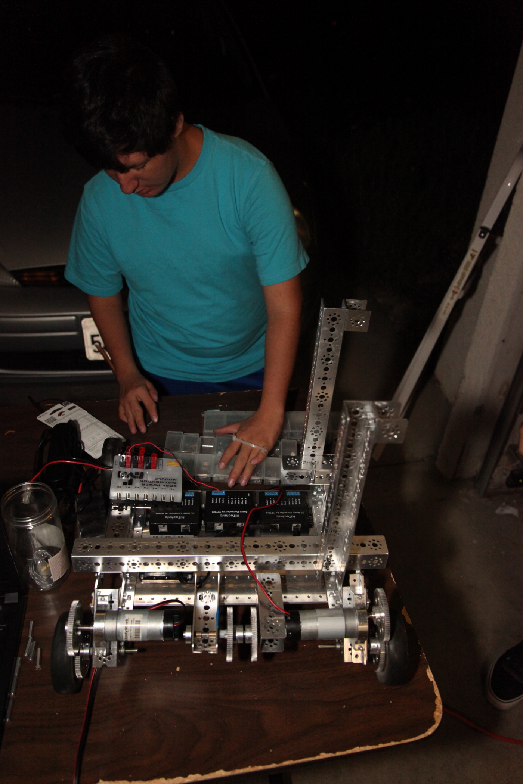

**Saturday – September 12, 2015 (FTC Kick-off Barbeque)**

The wait is finally over! Today both teams, Alpha and Omega, met and had a kick off barbeque. We had some amazing food, made by Mr. McMillan, and watched the game animation for this season. Res-Q looks like a challenging game, but will rise to the occasion! With nerves shaking and our minds racing, we began to discuss some ideas for robot design and what we want to accomplish. We also went over the rules and penalties for this year’s game. Both teams are super excited and ready to get started!



Monday – September 21, 2015

**Helping New Team Members**

**Goals:** Bill of Material (B.O.M.), team rules, notebook, meeting log, software section, 3D printer set up, basic chassis.

**Accomplishments:** We got the motors to spin on the practice bot, finished the B.O.M, we started on the software for the 3D printer, we revised our order list, did more programing, taught the new team members more programing hardware and notebook.

**Discoveries:** Pushing forward on both of the robot's control sticks caused one wheel to spin forward and the other to spin in reverse, but we fixed it by switching the wheel's spin direction.

**Plans:** Our future plans for the next meeting are to get the 3D printer fully operational, the robot running on four wheel drive, finish discussing the team rules, and finally to start prototyping arms and buckets.

**Author:** Joe Baughman



**A senior team member teaching the team how to 3D model**

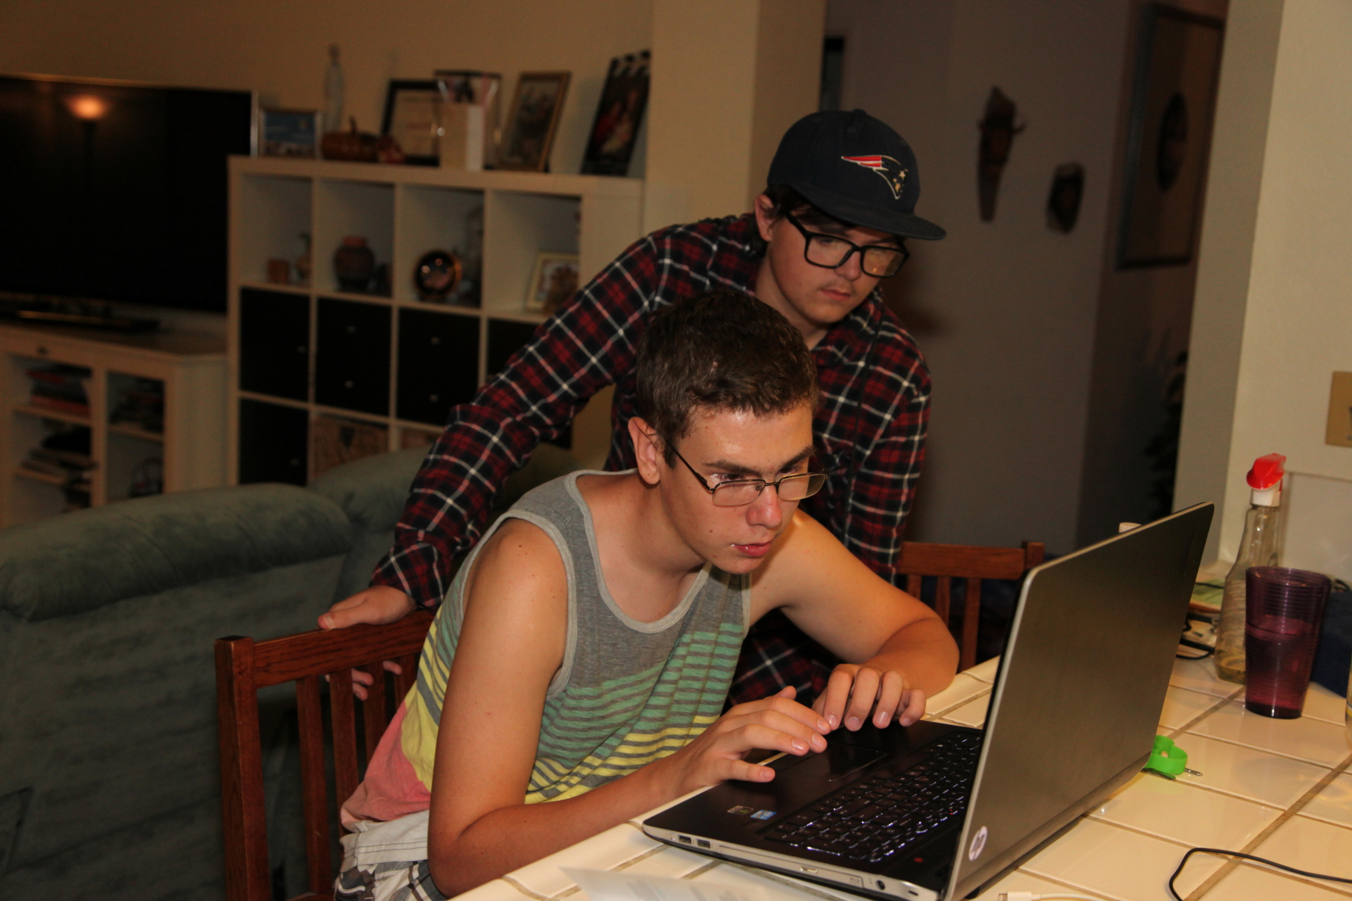

Thursday – September 24, 2015

**To Be Or Not To Be**

**Goals:** notebook, software section, 3d printer, basic chassis redesign, the chassis set up, calendar, arm ideas, different ideas for the chassis and wheels, we went over the requirements for the robot

**Accomplishments:** We decided on what your practice bot was going to be. We decided on a compromise between the Kracken chassis and the low rider chassis, which we had two separate groups working on and we decided to combine our two ideas and made something that should work, we might have to make a few adjustment, but the basic design is there. We also began working on getting wiring re setup, and getting that reorganized and not messy. We worked on the wheels and decided on tread as our final design so we can climb the mountain.

**Discoveries:** We found out that some designs of wheels weren’t very good so we decided against doing a three wheel bot and that was unexpected because most of our team members had expected one design to work but that did not. If we had a low rider chassis the bot would get high sighted and not be able to move so due to that discovery we adjusted our plan and made a high rider Kracken style chassis bot.

**Plans:** Get the tread on the bot so that we can work on driver practice and finish doing wiring layouts and getting the cord power distribution module hooked up and turning the two wheel drive to four wheel drive hooked up to the two motors and starting the mount for the arm

**Author:** Luke McMillan



Monday – September 28, 2015

**Reading And Prototyping**

**Goals:** Get the tread on the bot so that we can work on driver practice and finish doing wiring layouts and getting the cord power distribution module hooked up and turning the two wheel drive to four wheel drive hooked up to the two motors and starting the mount

**Accomplishments:** rookie programmer read and understood the first three lessons from module three and got the android studio along with git hub also the lieutenant programmer was able to start programming color sensors along with acoustic sensors. To add we were able to get our prototype two wheel chassis, hardware also did prototyping robotic arm.

**Discoveries**: we discovered working arm techniques like hooks that shot out to grab the bar and pull themselves up with a bucket that collected balls and blocks and dumped them into the scoring buckets.

**Plans:** Get the tread on the bot so that we can work on driver practice and finish doing wiring layouts and getting the cord power distribution module hooked up and turning the two wheel drive to four wheel drive hooked up to the two motors and starting the mount

**Author:** Immanuel Lawhon



Thursday – October 1, 2015

**Learning, Growing, Brainstorming and Designing**

**Goals:** Get the tread on the bot so that we can work on driver practice and finish doing wiring layouts and getting the cord power distribution module hooked up and turning the two wheel drive to four wheel drive hooked up to the two motors and starting the mount

**Accomplishments:** Software:I learned lots of stuff tonight! I know how to program tank drive and arcade mode.. but it wasn't until tonight that I really knew what I was doing, and I now know how to teach it properly. All because I took the time out to look on the FIRST website and read up on it more.

Hardware: we decided on an initial design for our arm and bucket. This design consists of a conveyor belt that feeds into a side dumping bucket. Also, we brainstormed an idea for lifting our bot in the end game. The design consists of a winch with a wire that runs up to a hook. The hook is to be Velcroed onto an extendable arm that would deploy during the end game.

**Discoveries:** The hardware team made some unexpected changes in arm design. We decided to try a solid mounted bucket that would dump rather than a bucket that would move on a rotational arm.

**Plans:** Software: learning the color sensor and gyro sensor. Making an arcade drive program. Hardware: make another cardboard bucket with correct measurements, and mount the winch. Design a model spool and test print. Figure out how to save the spool model into the Ekocycle format.

**Author:** Jeremiah Baughman



**A mentor teaching the team how to CAD motel**

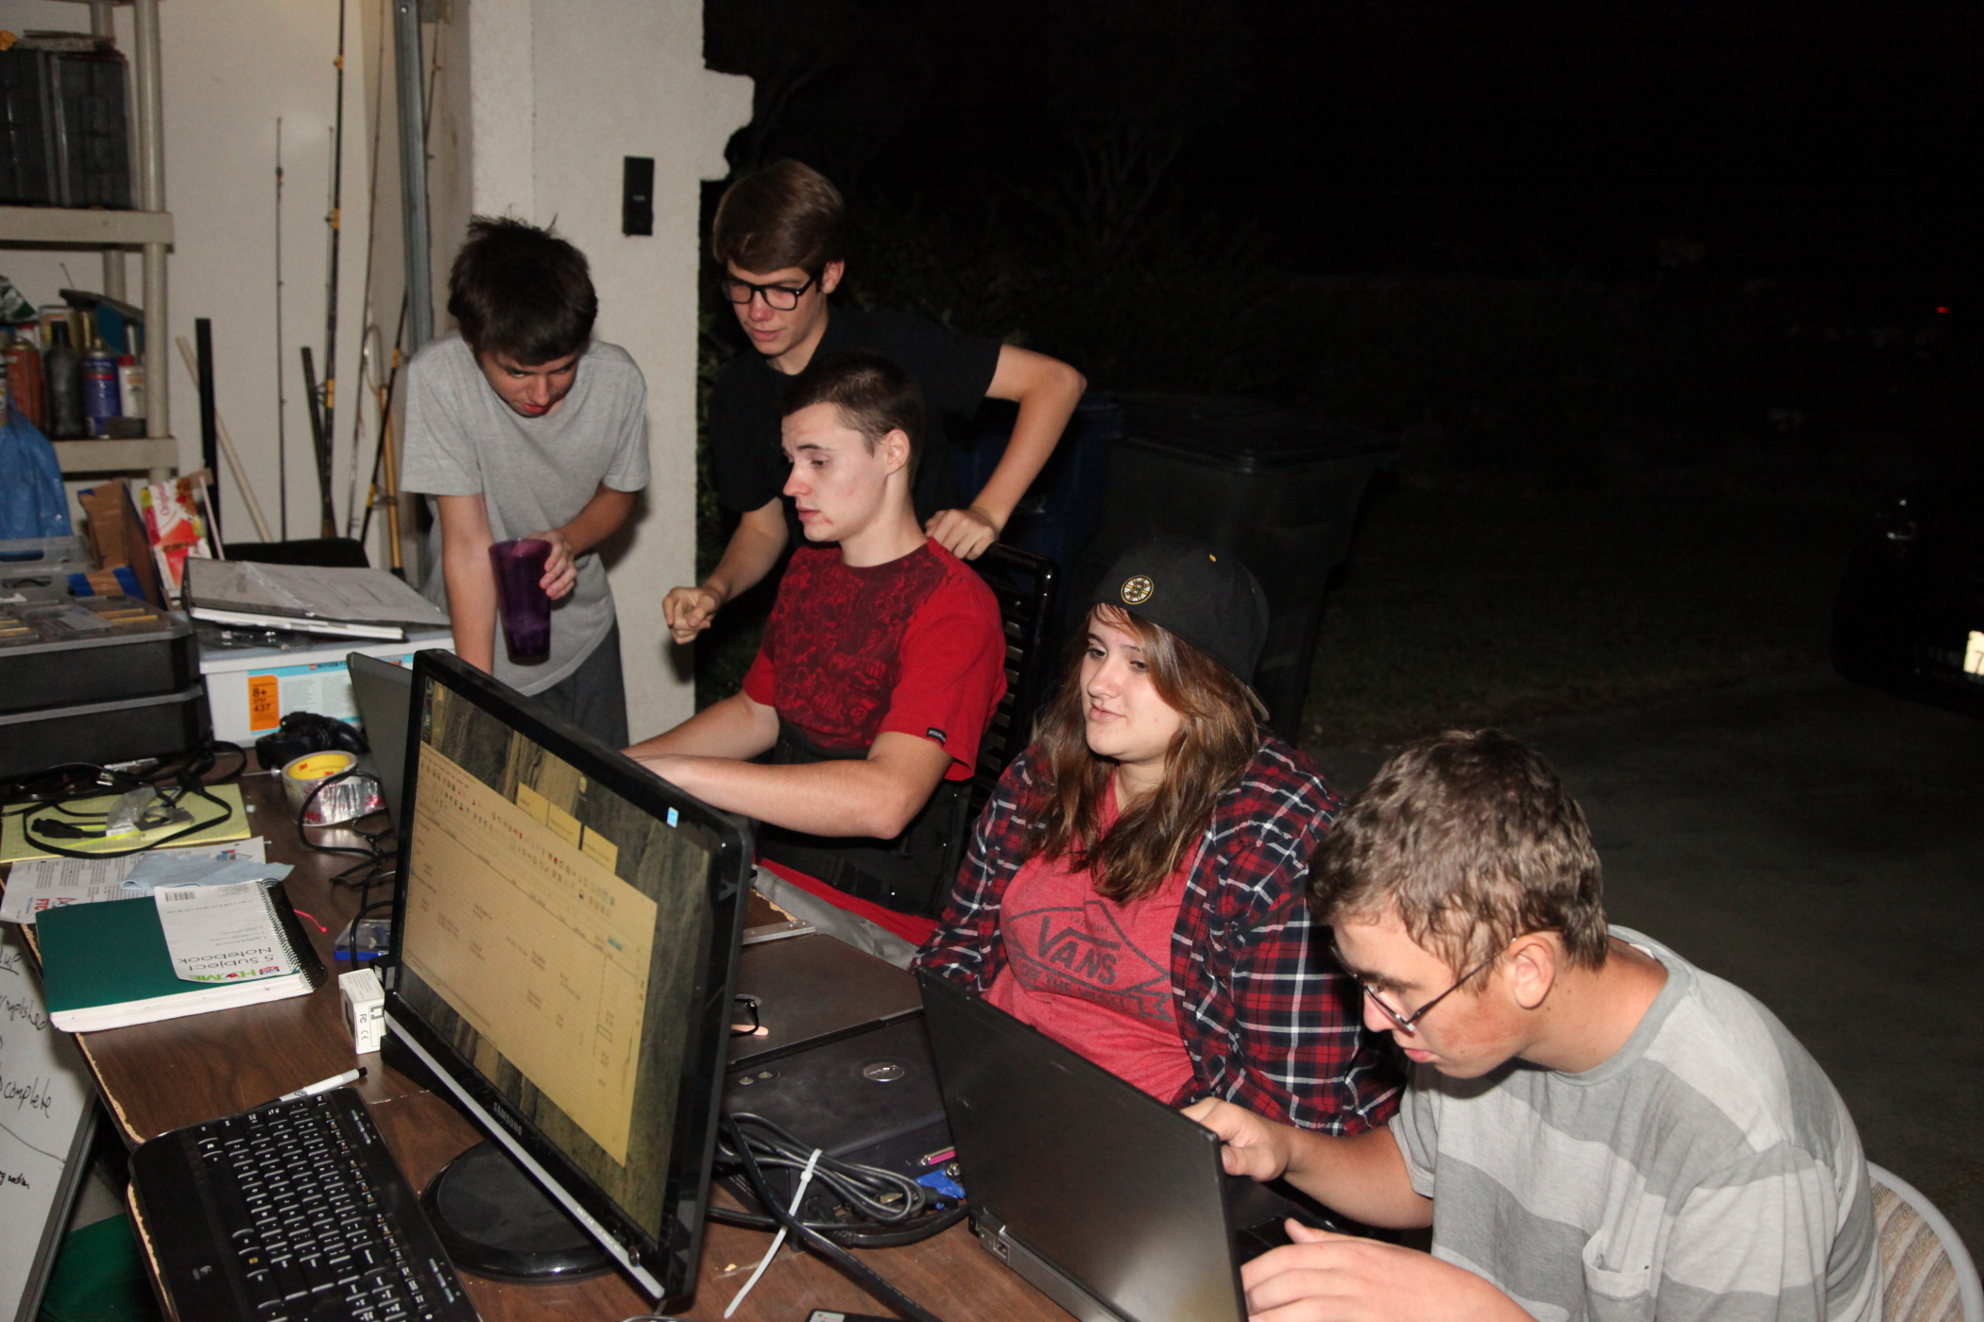

Monday – October 5, 2015

**Motors and Game Elements**

**Goals:** Software: learning the color sensor and gyro sensor. Making an arcade drive program. Hardware: make another cardboard bucket with correct measurements, and mount the winch. Design a model spool and test print. Figure out how to save the spool model into the Ekocycle format.

**Accomplishments:** The rookie programmer was able to set up color sensor programs on his computer and experiment with more coding in arcade mode and also tank mode and coming up with arm ideas and chassis ideas. Our main programer made a program that contains the following tasks: the use of two motors in arcade mode, and a motor for an arm using the game-pads A and B. we resigned the bucket model to be smoother and to hold more game elements, and reach farther out of dimensions, by releasing a trap door to guide the game elements into the buckets on the ramp. We received the field kit in the past week and started to examine some of the parts and setup, such as the buckets and the ramp.

**Discoveries:** There was a temperature error while attempting to print our first 3D model. Also the hardware team made an unexpected change to the bucket design after some examination of the field elements.

**Plans:** Get a working practice robot, test the software on the bot,

**Author:** Cierra Bachtelle/ Immanuel Lawhon



Thursday – October 8, 2015

**Tread and Building**

**Goals:** Get a driving practice robot, test the software on the bot. Build a bucket prototype

**Accomplishments:** We got the tread set up in the bot, and we got the bot to move using our teleop, we built a plastic prototype for a bucket.

**Discoveries:** Our original designs for the bucket dimensions did not fit, so we had to rework the design so that it fit onto the robot.

**Plans:** Continueto build the bucket and test how well the design works, also, prototype some ideas on how to complete other tasks.

**Author:** Kayla Bachtelle



**A prototype for an intake system**

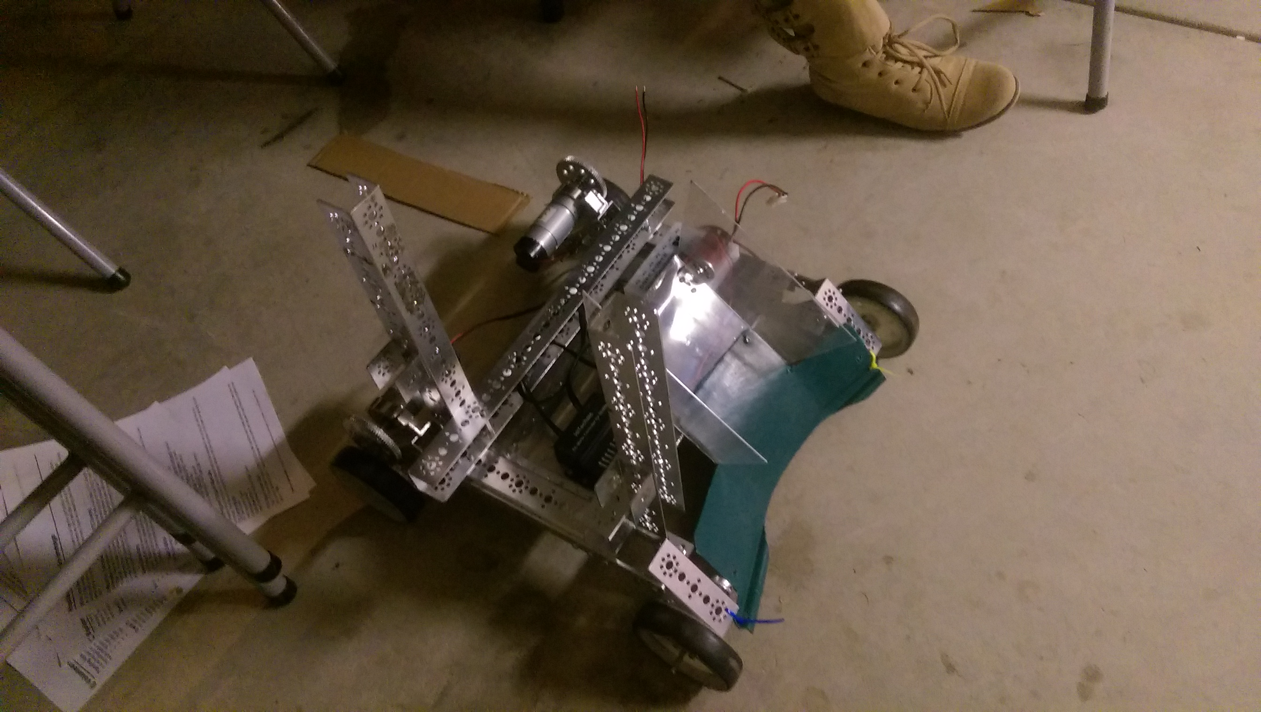

Thursday – October 12, 2015

**I Knew The Field Was Trouble When It Walked In**

**Goals:** Figure out how to program the robot to drive correctly, set up the field.

**Accomplishments:** We figured our how to move the robot the correct way. We got some driver practice in, we also got half of the field set up.

**Discoveries:** While putting together the parts for the field, some things did not go together as expected, and took some time to accomplish.

**Plans:** Get tables reset up, and get them organized, set up the rest of the field.

**Author:** Cierra Bachtelle



Thursday – October 15, 2015

**Tread Over Wheels**

**Goals:** Get tables reset up and get them organized, set up the rest of the field, get the notebook caught up. Work on more designs for the robot, such as arms and drive.

**Accomplishments:** Tonightwe got more of our field set up, and updated more of the notebook. The hardware team did a major overhaul on the robot's chassis and drive system. The robot now has a tank like tread setup, so that it may have a higher chance of climbing the ramp.

**Discoveries:** We discovered that our original design for our drive was not sufficient for this years game, so we decided to overhaul it. We had to come up with creative ways to put the field together since we thought some pieces were missing, and we could not find some of the necessary tools, so we improvised and got the job done.

**Plans:** Our plans for next Monday, are to finish assembling the mountain, and continue with the reconstruction of the robot. For software, we will continue to work with the teleop programs, as well as working with the sensors.

**Author:** Timothy Bloot



Monday – October 19, 2015

**Field Set Up and Rewiring**

**Goals:** Our plans are to finish assembling the mountain, and continue with the reconstruction of the robot. For software, we will continue to work with the teleop programs, as well as working with the sensors.

**Accomplishment:** Hardware: We were able to set up most of the field, also we were able to redesign the tread and add rubber traction. To add the hardware was able to rewire the robot after redesigning the tread. Our main programer worked a lot with the color sensors, along with setting up a few more computers. While our rookie software guy worked on the notebook and a few concepts for software.

**Discoveries:** We discovered that our programing for the color sensors was a little off, so we were working on programming color sensors to a device interface.

**Plans:** Get the robot to move, because we took apart the drive train, and we will need to rewire it tonight.

**Author:** Cierra Bachtelle/Immanuel Lawhon



Monday – October 22, 2015

**Moving and Designs**

**Goals:** We had plans to get the robot to move, because we took apart the drive train, and we will need to rewire it tonight.

**Accomplishments:** We got the robot to move, and we started making arm prototypes to score in the lower scoring goal. We came up with a design for scoring, also we made the tread work along with the rubber inserts and wired. Software: software was able to get the bot moving again but we had to change tank drive we made single stick arcade drive. Notebook: The note book revision team was able to accomplish working on space filler for our meeting log.

**Discoveries:** We found that the current tread drive train can not make the robot get over the ramp rods. When we rewired the robot our drive was reversed so we fixed that. We found that pour robot can not make it up the ramp on its own.

**Plans:** Build a folding arm that can reach the middle, and lower scoring goal, we also built a hook that can reach the high pull-up beam to help us reach the top of the ramp. We wrote our team bios for the notebook, and finish the meeting logs.

**Author:** Immanuel Lawhon/Scott Kidman



Monday – October 26, 2015

**Mounting and Formatting**

**Goals:** Hardware goals for tonight are to find a good place to mount our scoring arm, as well as a place for the linear slide. Software plans are to finish the arcade drive program and start working on autonomous programming. The notebook team plans to write down the team bios, and continue work on the notebook formatting.

**Accomplishments:** The hardware team mounted the base for the scoring arm, along with that they also mounted the linear slide for getting the hook all the way up to the lift bar for end game. The software team learned how to program autonomous movements, as well as teleop programs. The notebook team for the night worked on writing down team bios, and also continued designing formats for the notebook.

**Discoveries:** Our original mount for the winch slide was at too steep of an angle as well as being out of dimensions, so we redesigned, and built the arm to fit with in dimensions. The software team is running into some minor issues with programing servos in autonomous, but they are close.

**Plans:** For next week, hardware plans to build the bucket for scoring elements, and mount the hook and winch for end game strategy. Software plans to write some autonomous programs, and work on arcade drive.

**Author:** Timothy Bloot



Thursday – October 29, 2015

**Assembling and Knocking Down**

**Goals:** Hardware goals for tonight include designing the bucket, and building a prototype, remount the scoring arm, and find a new mounting spot for the zip line servo. Finally, we need to assemble and mount the two winches for the end game. Software goals include, check out the challenge video of this year again set up autonomous strategies, then figure out what our scoring would be. Also, we need to fix the android phones, and then move the robot in arcade drive. We would also like to order some much needed parts.

**Accomplishments:** We set the goals of what we want to do for the autonomous period, and figured out what the scoring would be. We fixed the problem on the android phones!!!!! Hardware was able to assemble an arm for knocking down zip liners, and for scoring except we have to re figure an arm. Software was able to learn more, and also make a few autonomous programs. Notebook was able to do more writing for past events.

**Discoveries:** The score would be 50 if we do want we wanted to do. We discovered that we mounted the zip-line servo. We also had to rebuild the arm joint because of a design change.

**Plans:** Figure out how to use the color sensor, and the gyro sensor.

**Author:** Immanuel Lawhon/ Tim Bloot



Thursday – November 5, 2015

**Making Things Simpler**

**Goals:** To get a retracting winch to pull our selves up. Get the final touches on the field. Get autonomous working smoothly and getting the rest of arcade drive set up. Also get more of the notebook events and sections done.

**Accomplishments:** Hardware was able to get a retracting winch done. We were able to finish off another more simple winch for the linear slide. Hook for the pull up bar that is attached to the retractable winch. Removed the short arm to score on the ramp and built a custom flipper for the zip-liners. Software was able to get some autonomous done and tested when driving in a square. And we were able to start gyro sensors. In the Notebook tonight we got the outreach section up to date, we also got our team vision finished.

**Discoveries:** Hardware we removed our small one stage scoring arm so that we can fit a winch in its place, and because we didn’t have enough time to finish both arms, and that’s another reason we removed the small arm. Software learned how to strip wire.

**Plans:** Next week, we plan to wire and get the long arm fully operational so we can pull our robot off the floor, start driver practice, learn gyro. Get the rest of the notebook up to date, and also take pictures of our robot and team members for the bios.

**Author:** Cierra Bachtelle/Immanuel Lawhon



Monday – November 9, 2015

**Making Space For Mounting Space**

**Goals:** Finish major hardware design, wright a competition ready program with the ability to move all the attachments on the robot,

**Accomplishments:** Software we made a competition ready teleop that we just need to test about, it contains the following tasks; motorized arm for right joy stick, arced drive on left joy stick, one servos using A and b and the other servo using x and y. Hardware we attached the final design for the climber levers on the side of the bot we had to cut a few pieces of Tetirx to make it turn out smoothly, we created mounting space so that we can mount our winch that we made last meeting, we modified our lift hook to be stronger.

**Discoveries:** Hardware had to edit Tetirx parts to make the new arm fit, software discovered how to program a motorized arm using the right joystick… there wasn’t any examples how to do that so we guess it completely and we figured it out together! It was a challenge! But we did it! It was awesome!

**Plans:** Finish wiring the new elements on the robot, which include three motors and two servos.

**Author:** Cierra Bachtelle



Thursday – November 12, 2015

**Elements and Game Rules**

**Goals:** Finish wiring the bot, finish mounting the end game hook, update the notebook, set up fields, build a practice robot.

**Accomplishments:** The hardware team finished wiring the new elements. The software team did some research on game rules as sensors. As a bonus, we celebrated a teammate's birthday today, and had cake!

**Discoveries:** The hardware team discovered that they need to remount a new design for a scoring arm.

**Plans:** Check the robot for appliance to the rules, because we are still behind the next meeting will be a two hour hardware craze, and then the last hour we will do complete software.

**Author:** Tim Bloot



Monday – November 16, 2015

**Hardware Goals and research**

**Goals:** Hardware: Finish the last amounts of wiring on the robot, and then give the robot over to the software team. Software: To make improvements on the program, and add functionality for the winch, check out the ready to go teleop for the competition.

**Accomplishments:** Hardware: We got the bot operational, we made a list of goals for hardware to finish before competition. Software: We got the bot moving with the teleop program, we programed the teleop correctly. We researched more on game and engineering notebook rules.

**Discoveries:** Hardware: We needed to speed up our process in order to be finished on time, we found out we need to replace wires to fix power management, for wiring configuration we discovered that we can no longer daisy-chain motors controllers together with the new programming. Software learned how to program servos that only use one button each! We learned how to program the slider using the right trigger, and left trigger. Right trigger is used to push the slider up, and the left trigger is used to bring the slider down.

**Plans:** Fix power management problem, and run teleop program.

**Author:** Cierra Bachtelle



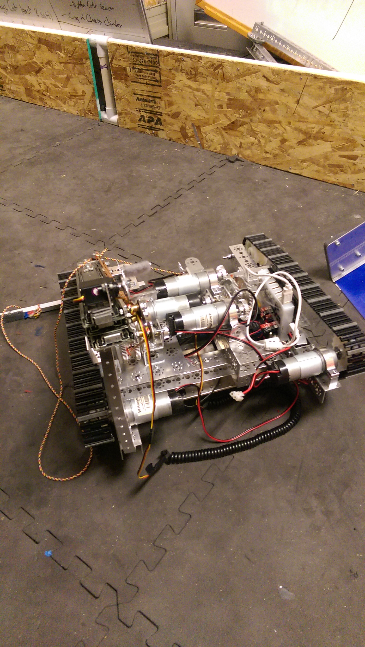

Thursday – November 19, 2015

**Releasing Climbers and Creating Flippers**

**Goals:** Finish flippers to release the climbers in end game, change out the medium to large gears one the winch for more torque to give more power to pull the robot up the ramp, replace small wire with lager wire that will carry more current because the motors weren’t getting enough power and they were running very slowly, move the winch to the center of gravity.

**Accomplishments:** Hardware: We got our shipment of parts that we got from Andy mark and Tetrix and then we replaced the lift up winch and added the gears to such winch and we created another climber release servo that will release these climbers, our rookie software team member created custom flipper and we created and we got the newest flipper on the opposite side of the bot and now we have a flipper on both sides and we got the color sensors. Software was able to add yet another servo named “hook” in their competition ready teleop.

**Discoveries:** Software discovered that hardware added an unplanned servo that had to be programmed. Hardware discovered that they need to replace the power distribution wire. We need to replace the parachute cable with caviler thread.

**Plans:**  We plan to meet on Saturday to get more progress finished.

**Author:** Cierra Bachtelle/Immanuel Lawhon



Saturday – November 21, 2015

**Adding and Wiring**

**Goals:** Get the robot rewired, and improve the teleop program,

**Accomplishments:** Hardware:We took off all attachments of the robot and then moved around our two motor controllers, and the core legacy module then added another motor controller. Rewired then and made it very clean by tucking away wires, and zip tying them under metal to keep it out of sight. Then remounted all of the attachments of the robot that we took off earlier in the day back onto the robot and moved our pullup winch into the center of gravity. We attached a large gear to the pullup winch also so it will have a 3 to 1 gear ratio.

**Discoveries:** The hardware team found out that we can't daisy chain power of the motor controllers, because they will run out of power, because of how much power was being used by Andy Mark motors. We were lucky that we didn’t burn out a motor controller, so we added wires from the core power module to all the servo controllers and motor controllers.

**Plans:** Continue to wire up the robot, and then get the bot off to the software team so that they can test out their programs.

**Author:** Scott Lloyd Kidman



Monday – November 23, 2015

**Programing and Replacing**

**Goals:** To finish the teleop program, and test it to see if it works. Make the other flipper and to replace the string on the Kevlar thread.

**Accomplishments:** We finished the program and tested it, it came out well. Hardware made the other flipper and replaced the string.

**Discoveries:** Hardware: Discovered the Kevlar string on the slider spool was getting wrapping in between, and wrapped around the axle. Software: Discovered that they couldn’t move the wheels because they kept losing power to that motor controller.

**Plans:** Hardware needs to wire servo controller, and add battery mount and phone mount onto the robot. Software plans to check out the teleop program again to make sure everything is good to go, and make sure its competition ready. Also maybe start on autonomies. We are going to meet Wednesday since thanksgiving is this Thursday.

**Author:** Kayla Bachtelle.



Wednesday – November 25, 2015

**Fixing Problems and Testing**

**Goals:** fix wiring, fix the lift side and finish it. Test the teleop program again, make adjustments to the program.

**Accomplishments:** Our software rookie was able to help our main programer try to fix the teleop problems, and also to try to configure the phones. We tested it out again, and it worked except we needed to make some adjustments. We haven't yet tested out the servos with the program, nor have we tested out the winch.

**Discoveries:** We need to have a better sense of meeting time management, so we are able to get more things done.

**Plans:** Make sure the teleop is ready to go!

**Author:** Kayla Bachtelle/ Immanuel Lawhon



Saturday – November 28, 2015

**Servos and Making Things Look Neat**

**Goals:** Finish all things related to hardware, such as robot wiring, lift slide winch, lift winch, and servos.

**Accomplishments:** We started the meeting off, by removing the linear slide from the robot, so that we may work on it separately from the robot chassis. One team worked on robot setting up new wiring management, as well as adding in the servo controller to the power gird. The other team did some upgrades on the slide, which included adding small wire guides for the new Kevlar thread, as well as adjusting the slide mounts for the chassis. Once the basic power wiring for the motor, and servo controllers was set up, the linear slide team was finished and we mounted the slide back on the robot. Next came the harder part of the day, which was routing all of the motor and servo wires through the robot chassis to make the wiring clean and neat. This task took up most of the rest day. Once we finally finished that, we finally were able to send the robot off to software, to test the teleop.

**Discoveries:** Some of the wires that we used were too short to reach where they needed to go, so we had to splice some pieces together, so that the wires would reach. Also, we seem to be having a problem controlling the servos, which we will investigate next meeting.

**Plans:** Fix the servo problems, and test out the teleop on then new wiring configuration.

**Author:** Tim Bloot



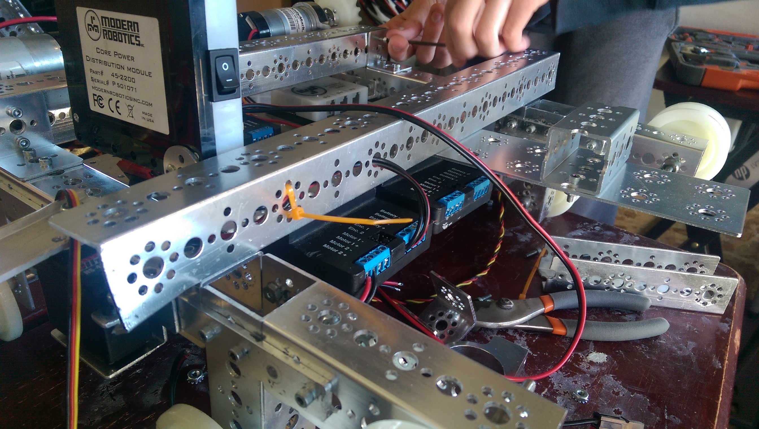**Attaching support to stabilize chassis**

Thursday – December 3, 2015

**Reaching to Score and Improving**

**Goals:** Getting the teleop program ready for competition, and add the new motors, and servos that has been added to the robot. String up the lift winch create then mount a servo to flip the climbers on the climb to the top of the ramp, to see in teleop if hardware aspects worked as planned, and it can successfully reach goals.

**Accomplishments:** Hardware: We wired the arm to reach the lower two of the three ramp scoring. We also mounted that arm to the robot. We strung up our pull-up winch for the ramp pullup bar. We mounted onto the scoring arm a bucket with a servo and motor wired. We improved the teleop, and added the new motor to the program.

**Discoveries:** We tested if the pull up winch was mounted into the center of gravity, and it seamed to there too which saved us a lot of time. We ran into a problem with the servo controller, so we couldn't test out the teleop.

**Plans:** To finish the bucket on the end of the scoring arm, finish our intake system for the bucket. We need to make sure the teleop is ready for competition, and add another servo, and motor to the program.

**Author:** Joe Baughman



Friday – December 4, 2015

**Realizing and Fixing Whats Wrong**

**Goals:** To finish the bucket on the end of the scoring arm, finish our intake system for the bucket. We need to make sure the teleop is ready for competition, and add another servo, and motor to the program.

**Accomplishments:** Software: We finally realized what's wrong with the servos in the program! We fixed it! And it worked perfectly! We also checked out the new servo and motors that we added to the program.

**Discoveries:** We discovered what was wrong with the servo.

**Plans:** Finish teleop, and autonomy, and configure the new phones.

**Author:** Cierra Bachtelle



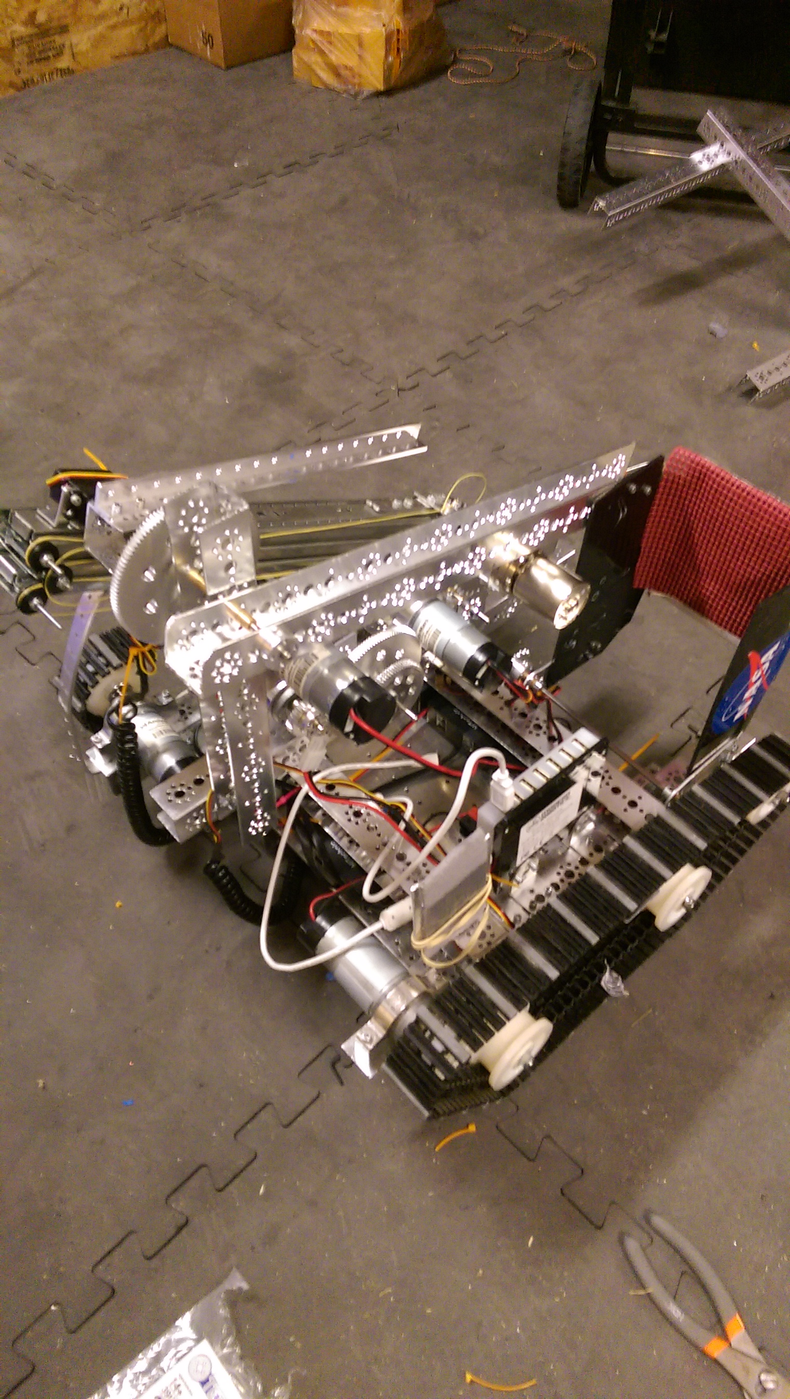

Saturday – December 5, 2015

**Testing the Teleop and Reading the Rules**

**Goals:** Finish teleop, autonomy, and configure the new phones.

**Accomplishments:** Software: finished programming all the new motors and servos that was added to the robot. We tested the teleop, which was successful. They also configured new phones and read extra rules in the manual. Following details will be posted in the software section of the notebook.

**Discoveries:** We discovered which servo was messed up and were able to fix it, we also discovered that the linear slide has been acting up, so we will try to fix it on Monday.

**Plans:** Fix linear slide.

**Author:** Immanuel Lawhon



Monday – December 7, 2015

**Making Adjustments in the Autonomy Program**

**Goals:** Drivers practice, and finish intake system.

**Accomplishments:** Hardware We added both sides of the servos, we made the ball intake system made of surgical tubing, and large cut zip-tie. And chained the intake as well. We fixed a minor problem in the teleop, and we were adjusting the autonomy program, it is coming out well. We are in the progress of finishing the software section. We also celebrated the person that's head of the notebooks birthday.

**Discoveries:** That we need to hand off hardware pretty much now, so we are pulling extra meetings, so we can get the driver practice we need.

**Plans:** Driver practice, and pack for this weekend's competition

**Author:** Scott Kidman



Thursday – December 10, 2015

**Goals:** Prepare the robot for this weekends competition. Finish making our table tri-fold. Do some driver practice drills.

**Accomplishments:** We did some driver practice, and tested autonomies. The tri-fold is almost completed.

**Discoveries:** Our driver practice went well, but some of the functions did not work as we expected.

**Plans:** More driver practice and pack for this weekend's competition.

**Author:** Tim Bloot



Friday – December 11, 2015

**Day Before First Competition**

**Goals:** Driver Practice, pack for tomorrow's competition.

**Accomplishments:** We packed the cars for the competition, and finished the tri-fold.

**Discoveries:** We snapped the linear slide winch line.

**Plans:** Go out tomorrow, and HAVE SOME FUN!

**Author:** Timothy Bloot



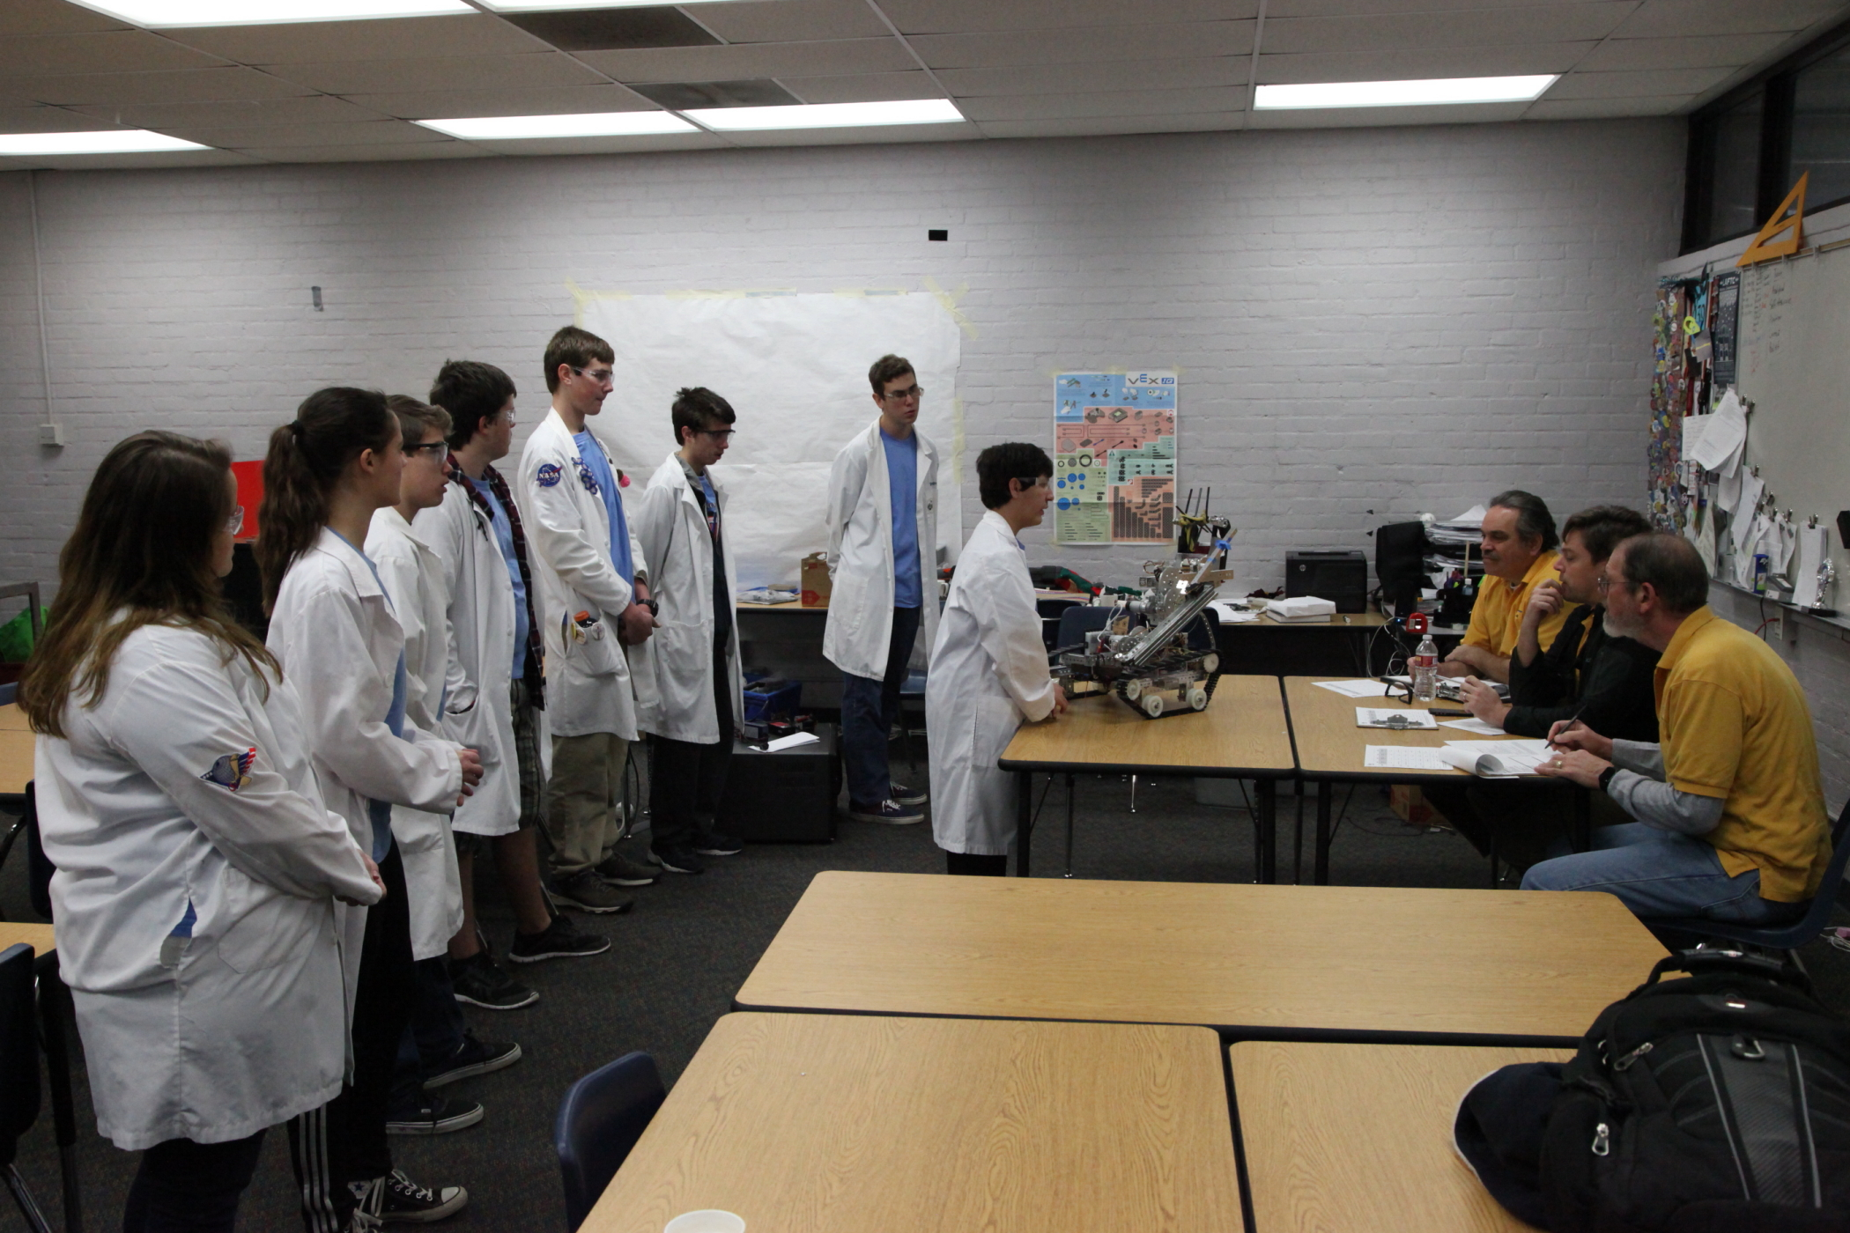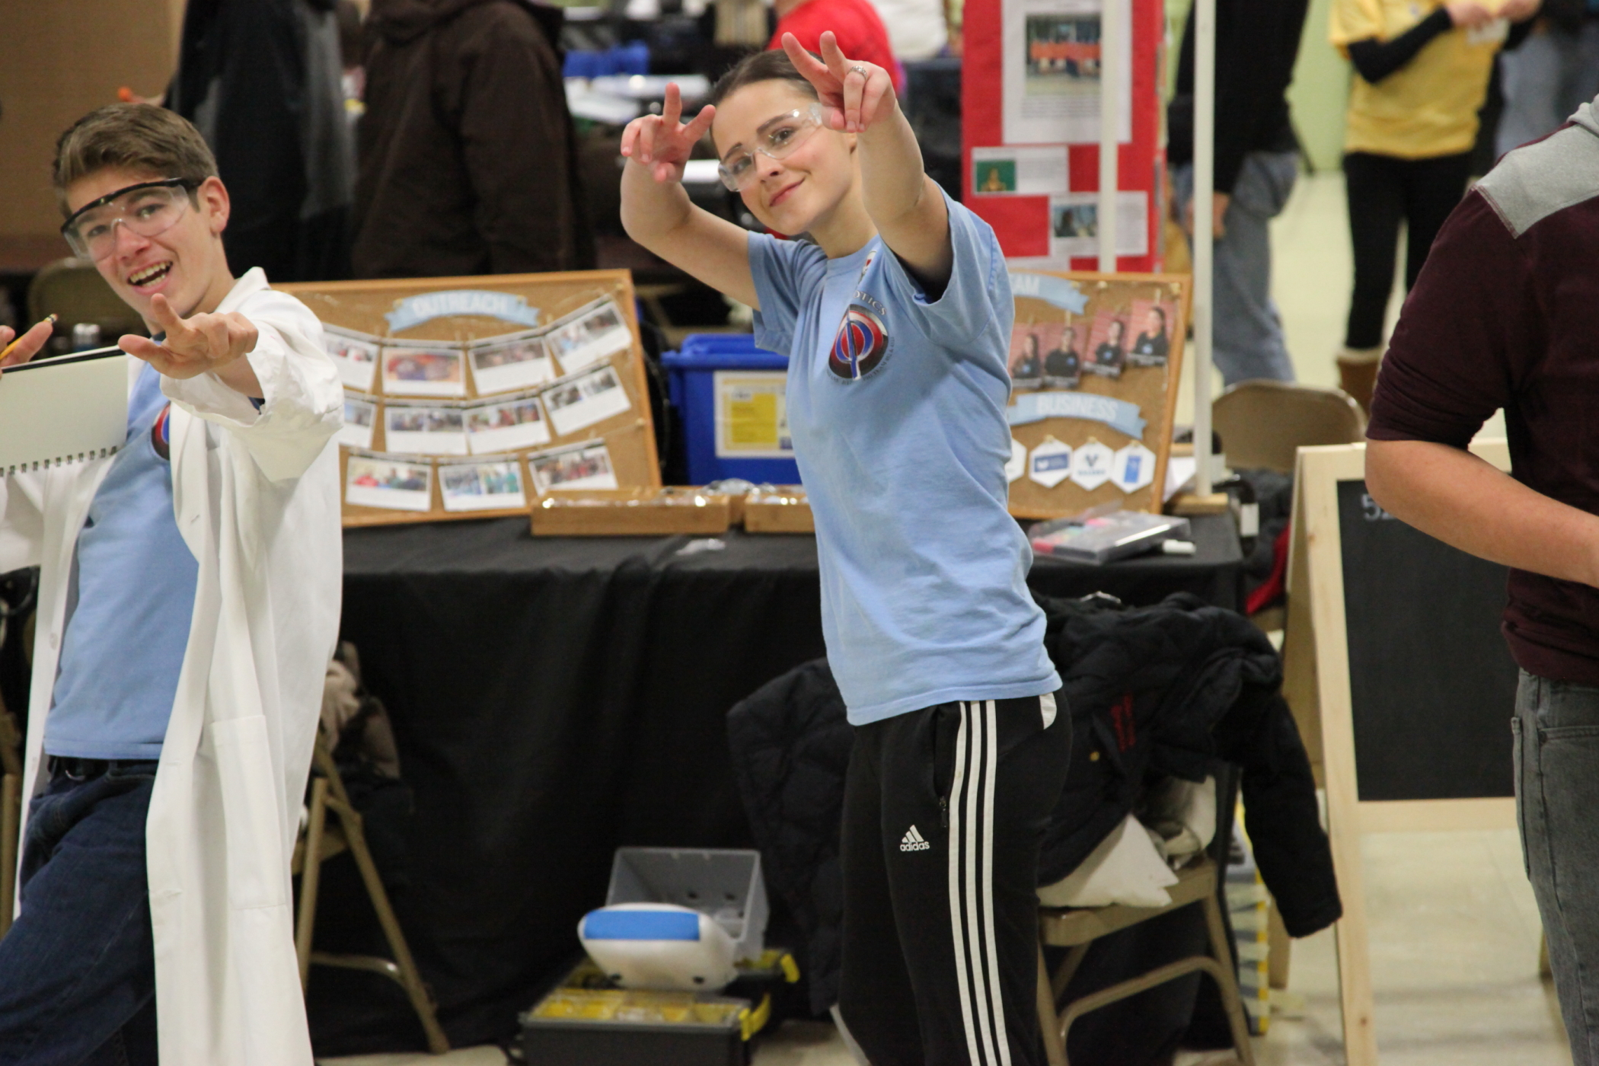

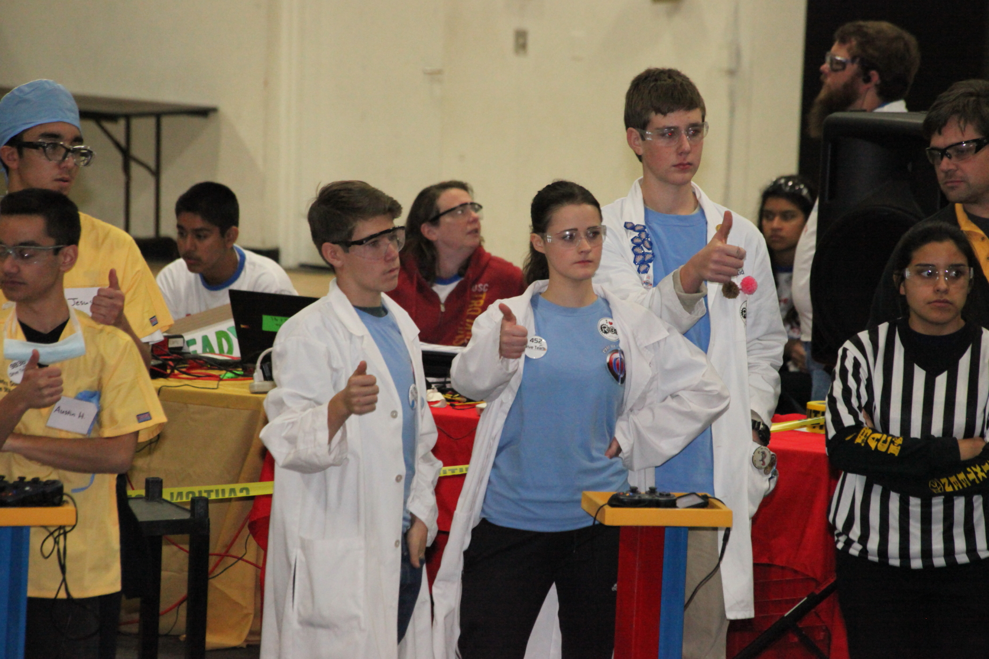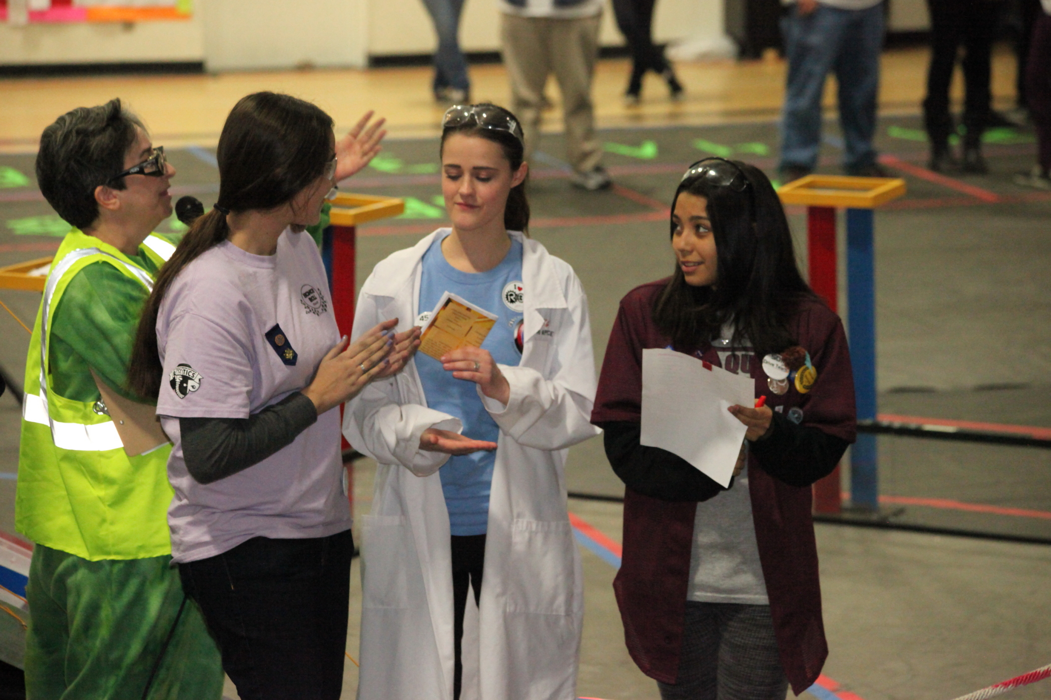

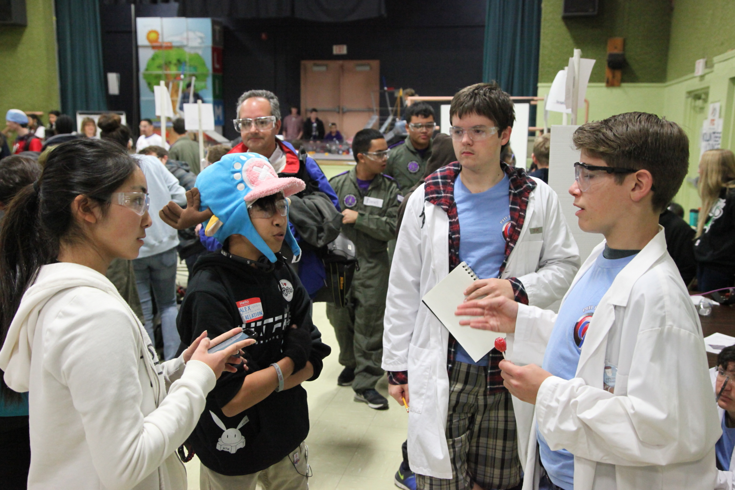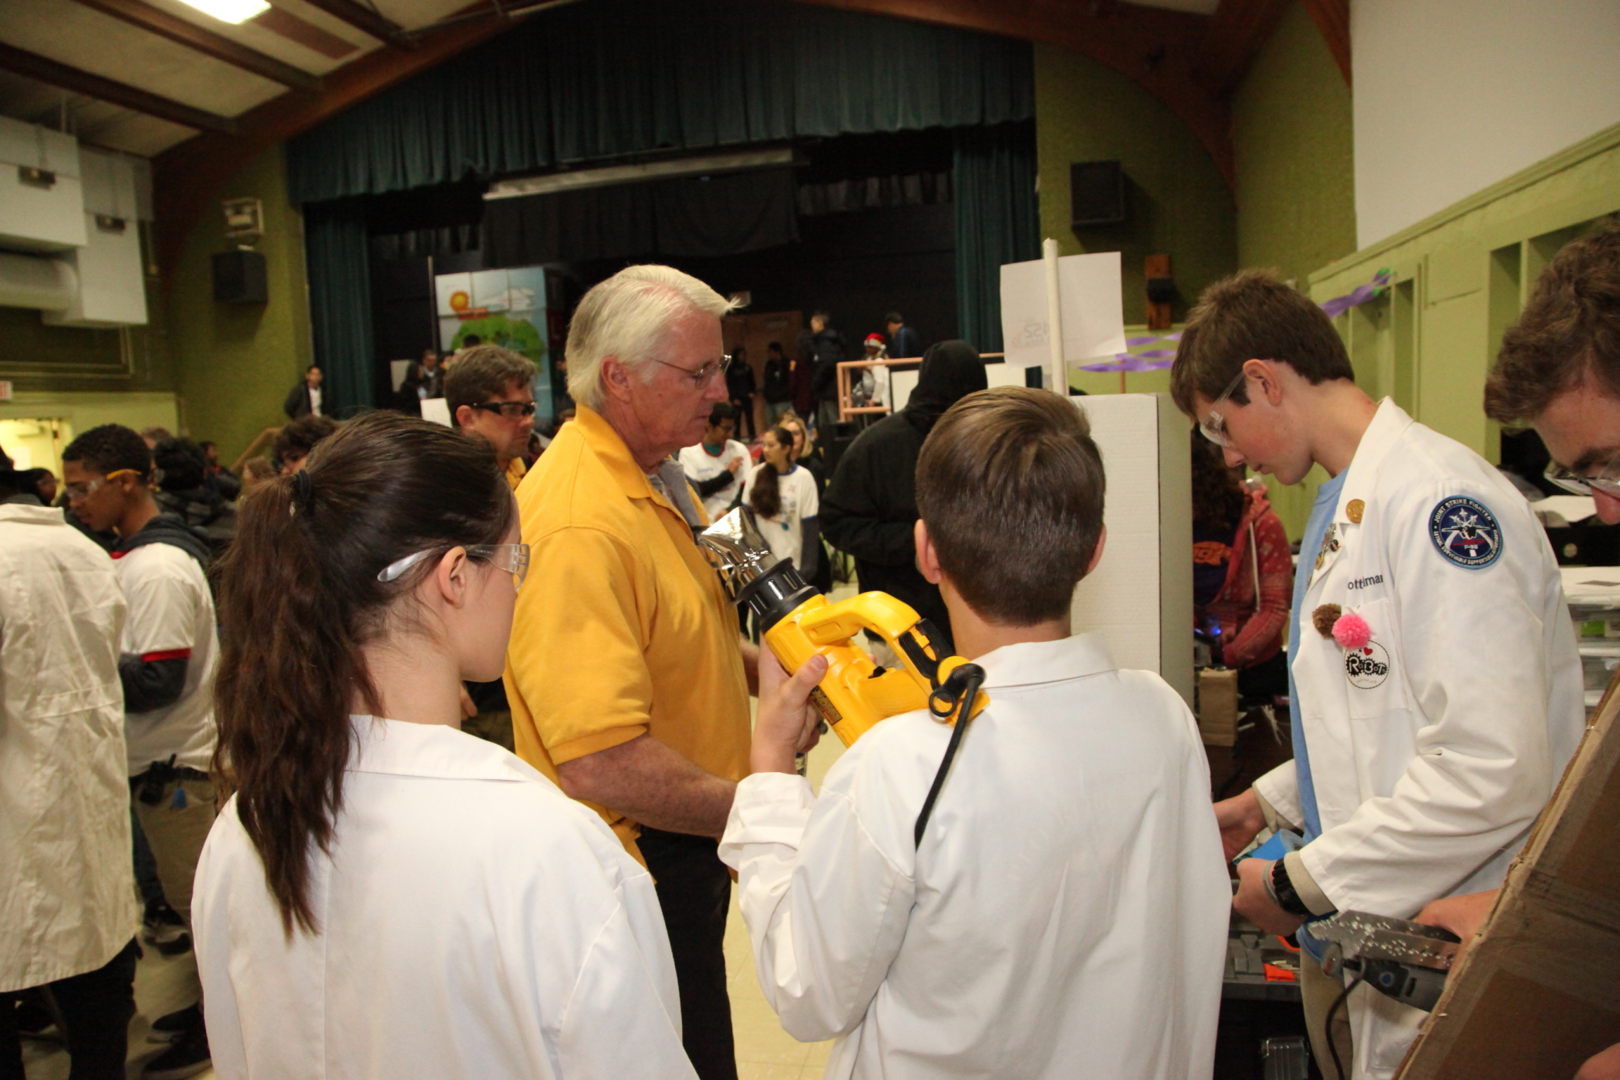

Wednesday – December 16, 2015

**Extending and Contracting**

**Goals:** To learn how to move a servo in a teleop program.

**Accomplishments:** We created a program that will move forward half way extended, when you hit the A button on the game pad 1, and when you hit game pad 1 button B it will go back to its not extended position.

**Discoveries:** We discovered how to create a program in teleop that will move a servo to the click of a button.

**Plans:** Program a teleop program that will move a motor, or create an anatomy program that will move the robot.

**Author:** Scott Kidman



Monday – December 21, 2015

**Getting Better Grip on the Ramp and Teaching New Members**

**Goals:** Study the new robot chassis, and decide what needs to be done next. The Software team will be working on teaching the software members how to configure the phones, motors, and servos.

**Accomplishments:** We added surgical rubber tubing to our tank tread, so that we could get better grip on the ramp, we created the design we plan on using to attach a hook to the pull up bar, and we started creating that design. We created a prototype a wheelie-bar to get traction on the floor when we on the ramp. We taught another member how to program servos, and we taught them how to configure the robot with the phones and how to work the phones. One of our new team members made a working servo program and configured the phones to use that program and he also tested it

**Discoveries:** One of our new team members discovered that his program for servos worked. The hardware team discovered some new parts that we will be using on the robot for endgame robot lifting.

**Plans:** Create a working design of the prototype wheelie-bar, finish the build of the design to attach a hook to the pull up bar.

**Author:** All Team



Monday – December 28, 2015

**Measuring and Cutting the Shielding**

**Goals:** We are figuring out encoders, and we started to make an autonomy with encoders to move two feet forwards, to use a test servo program that will test what servos are burned out.

**Accomplishments:** We measured dimensions to make shielding, and we cut the shielding into parts to be mounted.

**Discoveries:** The encoder degree measurements are different than we expected, so we need to adjust to make it work.

**Plans:** We plan to finish the encoder program to test out. We plan to meet Wednesday with our sister team and learn how to work gyro.

**Author:** Scott Kidman and Kayla Bachtelle



Monday – January 4, 2016

**Wiring, Testing, and Developing**

**Goals:** Hardware: Finish wiring, add motor encoders, write up a wiring diagram, prototype a hook, and finish the bucket. Software: Learn to work with the core device interface, finish motor encoder test program if completed move on to gyro program. Notebook: Write up meeting log titles.

**Accomplishments:** Hardware: wired and tested the winch, mounted electronics for the bucket, and hooked up a servo for the hook. Software: developed an encoder testing program, as well as a test setup for servos.

**Discoveries:** Hardware: We ran into a problem with the plastic shielding, when it cracked while we were cutting the servo flap. Software: we had to change a power management set up with the servos because our original configuration did not work.

**Plans:** We plan to meet tomorrow “Tuesday” to work on motor encoders and robot construction.

**Author:** Cierra Bachtelle



**Note that the motors are under the chassis so that we have more mounting space**

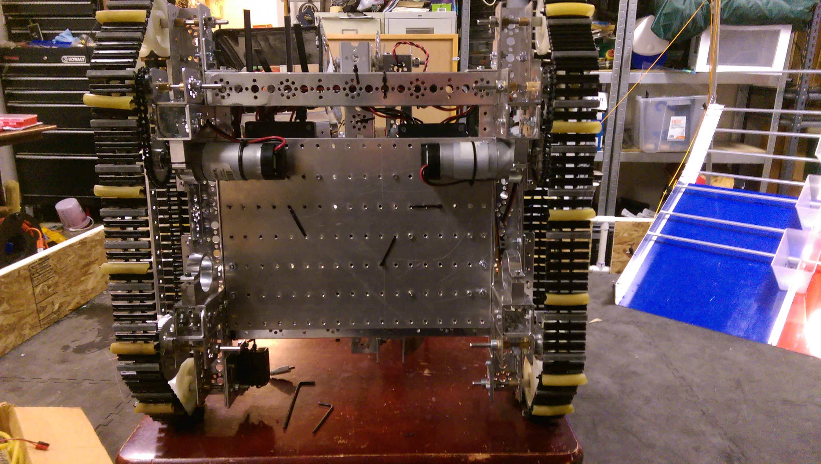

Tuesday – January 5, 2016

**Promoting and Programming**

**Goals:** Get a working teleop

**Accomplishments:** Hardware continued construction on the robot, and made a new servo trapdoor. OurRookie software programmer was promoted to sergeant and used that to make a new teleop which has three motors and a servo programmed

**Discoveries:** The hardware team found out that our servo placement on the robot may not be in the most ideal position, so we may decide to change the mount.

**Plans:** Hardware: Work on wiring. Software: Driving, work on a working teleop, and encoders. Notebook: Working on the trifold, work on other sections of our notebook, and take pictures. Add the other components into the competition teleop program.

**Author:** Immanuel Lawhorn



Thursday – January 7, 2016

**Work Hard, Play Hard**

**Goals:** Hardware: Work on wiring. Software: Driving, work on a working teleop, and encoders. Notebook: Working on the trifold, work on other sections of our notebook, and take pictures. Add the other components into the competition teleop program.

**Accomplishments:** We added the other motors and servos into the competition teleop, it is ready to test out but we are waiting for the new controllers. The wiring on the robot is almost finished!

**Discoveries:** Our wiring is turning out to be a larger task than we had originally assumed, we may need an extra meeting to finish it all in time.

**Plans:** Test the competition teleop. Figure out how to fix the bugs in the encoder program.

**Author:** Luke McMillan



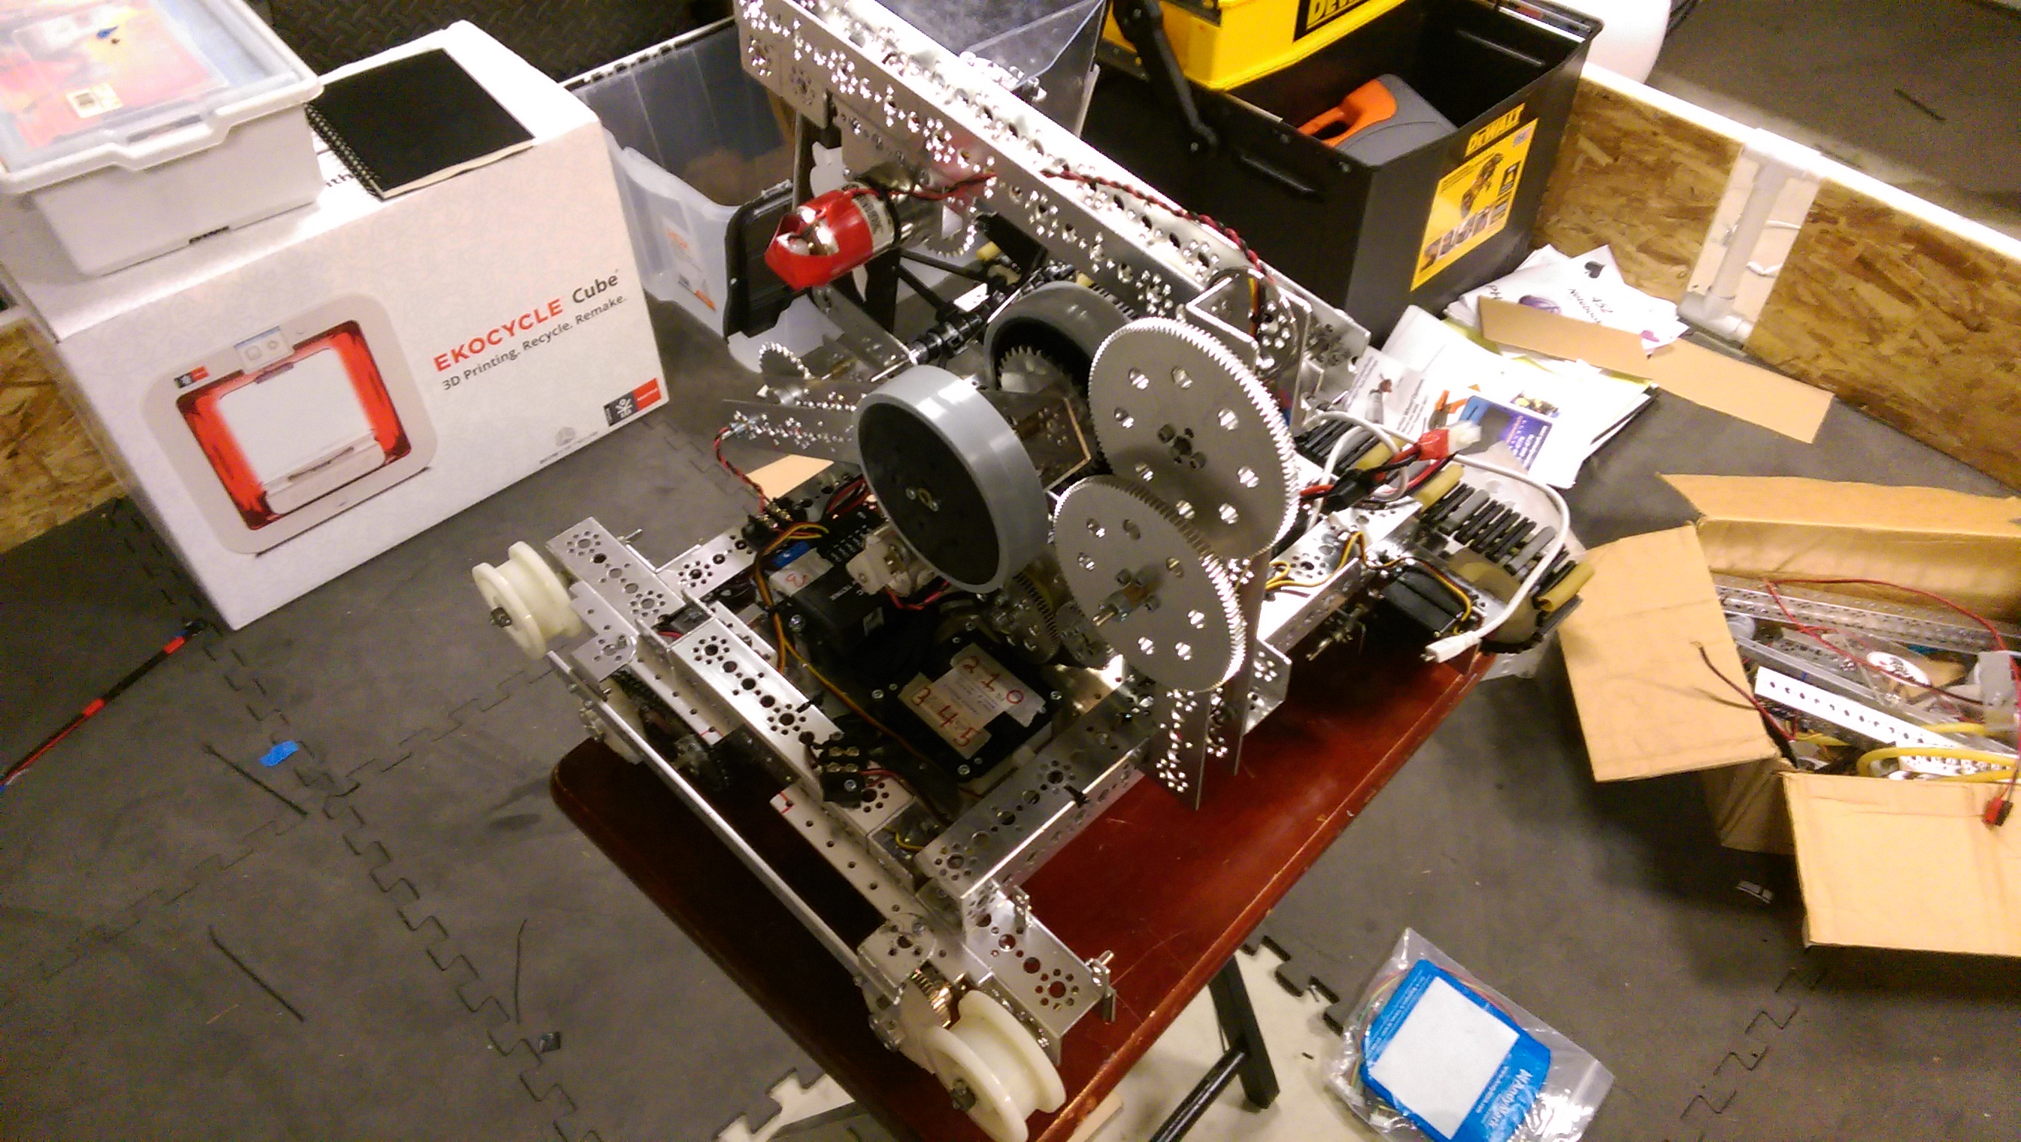

**Current robot design**

Monday – January 11, 2016

**Making Movement and Making Improvements**

**Goals:** Practice judging, finish the side shielding for the robot, To get the motor encoders running into our autonomy and test it. To test the teleop and improve it.

**Accomplishments:** We got the motor encoders move in our autonomy! We tested the teleop and improved it some bit. Hardware was able to get the side shields on by cutting, and mounting them.

**Discoveries:** We discovered how to move motor encoders, we ran into a roadblock when our string for lifting the robot snapped during software testing.

**Plans:** Improve the teleop and finish it, make the autonomies for competition, replace the winch string. Mount the second shield for the tread, practice the competition judging.

**Author:** Immanuel, Tim, Joe



**A picture of how the wheel will extend in game**

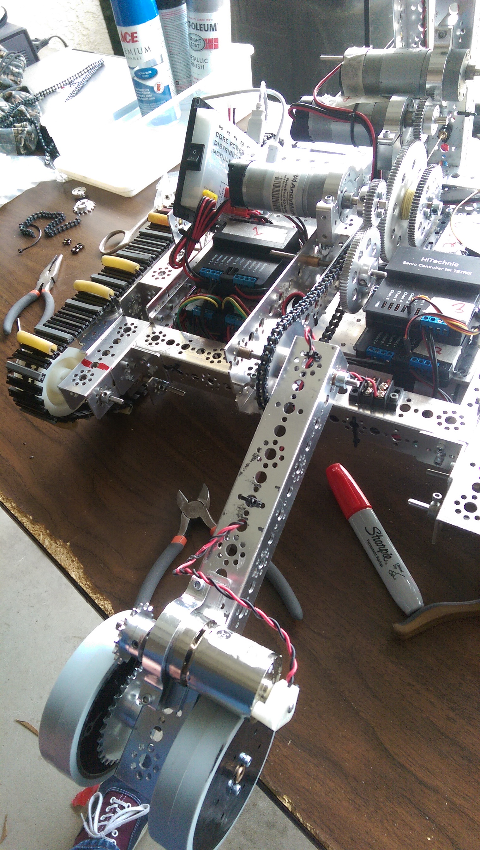

Tuesday – January 12, 2016

**Making Holders**

**Goals:** Finish the robot shielding, work on the autonomies, and the teleop program. Prototype a way to dispense the preloaded climbers during autonomous program.

**Accomplishments:** we successfully made a holder for the climbers, and finished the shielding.

**Discoveries:** We measured one of the mount holes wrong the first time for the side shielding.

**Plans:** Paint the Shielding

**Author:** Tim Bloot



Thursday – January 14, 2016

**Solving Problems and Testing**

**Goals:** Finish the whip and test out all of the teleop functions. Do some driver practice.

**Accomplishments:** We solved the problems with the whip mounting, and designed an effective mount and release. We successfully tested out all of the motor functions.

**Discoveries:** We are having some problems with power connection, so we will be needing to make new power connectors.

**Plans:** Once the ordered parts arrive, we will be assembling the remaining chain parts.

**Author:** Tim Bloot



Saturday – January 16, 2016

**Goals:** The parts Finally arrived! Today our focus is to make the robot fully funtional. This includes setting up all chain. Also, if we have time we may start building prats for the Two-Face Protocol.

**Accomplishments:** Thankfully, we had the time to get all of the chain and other parts mounted on the robot, making it fully operational! Also, we completed the shielding and gave it a paint job.

**Discoveries:** We found out why the left drive was about half speed, its because the motor was bad. Also, we had to mount a chain tension to ensure that there is no slippage during operation.

**Plans:** Mount the robot shielding, have driver practice drills, test out autonomies, and continue work on the encoders.

**Author:** Jeremiah Baughman



Monday – January 18, 2015

**Our Two Face Protocol Design and Driving Practice**

**Goals:** Mount the robot shielding, have driver practice drills, test out autonomies, and continue work on the encoders.

**Accomplishments:** We finished building the other half of the two face protocol design. We mounted the shielding we tested out antonymous, and we did some driver practice drills.

**Discoveries:** We found out why the left drive was about half speed, its because the motor was bad.

**Plans:** Driver practice for the rest of the week until the competition on Saturday.

**Author:** Scott Kidman



**Intake System**

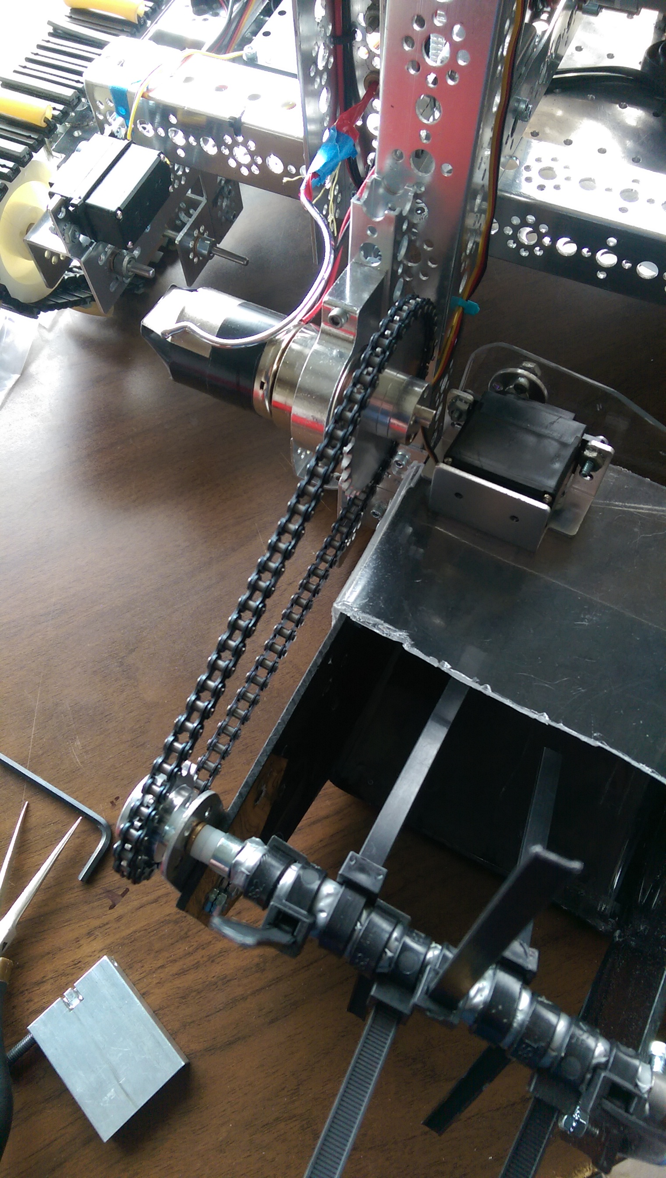

Tuesday – January 19, 2016

**Techniques and Mounting**

**Goals:** Driver practice and continue work on autonomies.

**Accomplishments:** Tonight, we did driver practice drills, and worked on more techniques for climbing the ramp and maneuvering around the field. We continued to work on our autonomy programs as well as encoders. We also mounted the blue arm set and made sure that all of the wiring was configured correctly.

**Discoveries:** We were having a power management problem with the motor controllers, and had to adjust the wire connectors.

**Plans:** Driver practice, and prepare for this weekend's competition.

**Author:** Timothy Bloot



Wednesday – January 20, 2016

**Whomp! There it Went it Broke**

**Goals:** Driver practice, and begin printing updated versions of the notebook. Also, the software team will be working on the autonomies.

**Accomplishments:** We got some driver practice in, and had to adjust some o\f the wire connections.

**Discoveries:** Unfortunately, the servos are not functioning properly. This could be a power problem, a connection problem, a broken part, or even a software bug. We will have to troubleshoot the problem next meeting.

**Plans:** Fix the servos and prepare for the competition

**Author:** Joe Baughman



Thursday – January 21, 2016

**Goals:** To pack, to fix a problem of wires jiggling loose, fix a problem of servos not getting power, finish printing out our notebook sections, get more driver practice, mount number.

**Accomplishments:** Hardware:We fixed our problems with servos not getting power, we believe that we fixed the wiring problem. We got driver practice. Software: Finished up our software section of our notebook. Sargent Immanuel label the major programmed parts of the bot that we are using for the competition and completed part of the software section.

**Discoveries:** We discovered that even tho, the servo controller's light is on it doesn’t me that the black wire has connection, and that discovery is how we fixed our servo not getting power.

**Plans:** Have fun at our competition, while giving glory to our God.

**Author:** Cierra Bachtelle/Scott Kidman

